1

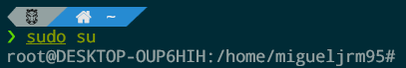



2



3



4



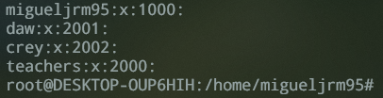

5





It seems that the system don’t create a home directory, so if you try to switch to that user you will get an error message saying that there is not a home folder assign to that user and the action will be denied.